2A Boys Individual Preview: Wold All The Way To The Promise Land
AddThis Sharing Buttons
Share to Facebook
438
Share to Twitter
Share to Print
Share to More
ILLINOIS XC 2013: PRESEASON RANKINGS
Tony Jones
Aug 30, 2013

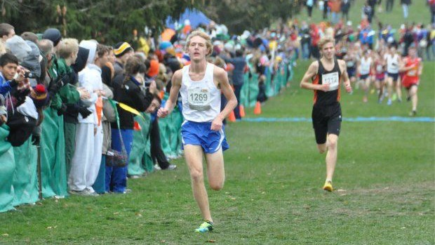

You better take notice! Do not sleep on the 2A Boys cross country scene this fall. If you dare to blink and turn your head on the middle classification, you are sure to miss something special this fall. There will be significant number of top 50 returners despite graduation and classification defections. Glen Ellyn Glenbard South’s John Wold returns as the defending champion and will have a lot to say how fast the league is this season.
1. John Wold (Sr.) Glen Ellyn (Glenbard South)- Defending state champion; 4:20/1:54- Don’t be fooled by the less than outstanding track marks for someone of Wold’s stature. Sure, he won the 800m title, but the spring season was not spectacular because of persistent health issues. This kid has been injured more often than not like his predecessor Micah VanDenend. If you recall, it was VanDenend that everyone was talking about with great promise if not for the injury bug back in ’99-00. Finally, late in the 2001 xc season he caught fire and blitzed his way through the state series and upset the favorite Sam Romanoski (Lake Zurich) for the 2A crown. VanDenend’s health would hold up in the subsequent track season and he won the state 3200m title along with a 9:03 personal best. Could it be déjà vu all over again in terms of the same Raider greatness for a senior year campaign? Stay tuned!
2. Johnny Leverenz (Sr.) Danville- 9th; 9:25/4:23/1:53- Despite coming in with state championship credentials (3A 800m champ), Leverenz probably won’t mind Wold taking up most of the spotlight this fall. It will just be a matter of continued growth and progression on the grass for Leverenz and then he will see where stands in November. No one is saying that he will overthrow Wold but he can make it difficult.
3. Jake Hoffert (Jr.) Yorkville- 12th; 9:37/4:28- Jake Hoffert is already ahead of last year’s all-state pace if you tally the solid credentials that he amassed this past spring. Everyone knows that a solid track season is usually a successful formula for cross country. Hoffert is sure to have a monster harrier campaign this fall. He recently competed in the Detweiller at Dark meet and placed second in 15:14.
4. Luke Hoffert (Jr.) Yorkville- 15th; 9:33/4:27- With credentials as identical as his twin Jake it is basically a pick em for the classifications best duo. Luke had a great summer of training that culminated with a great run at Detweiller at Dark meet in late July. He finished one second behind his brother in 15:15.
5. Joe Singleton (Sr.) Glen Ellyn (Glenbard South)- 6th; 9:42- when healthy Singleton is one of the best runners in the state. Unfortunately, he was on pace to have a marvelous track season but it was halted in late April/early May due to injury. If all goes well, he will be up and running again alongside his mate Jon Wold.
6. Forrest Smoes (Sr.) Mahomet-Seymour- 11th; 9:43/4:33- Running behind top runner Johnathan Schaap the past few years have paid off wonderfully. Now, it’s time for Smoes to take the lead mantle and run off into the sunset. He will be vying for a top five position this year at state.
7. J.D. Lafayette (Sr.) Normal (University)- 45th; 4:18/1:55/50.65- He is one of the state’s top all around runners with a great blend of speed and distance. According to Coach Lester Hampton, Lafayette is ready to take a leap toward becoming a good long distance runner. Hopefully a strong summer of running will pay off late in the fall.
8. Sam Doud (Sr.) Bloomington- 72nd; 9:22/4:32- Doud is already a much improved runner entering his senior campaign after a monster track season in which he placed fourth in the 3200m. The expectations of a strong fall were already in the works this summer with a ton of solid runs and workouts. Now, it will be interesting to see how things shape out this fall.
9. Simon Thorpe (Sr.) Dixon- 21st; 9:28/4:20- The top runner in the western part of the state is ready to make a big statement this fall and be among the very elite runners in the classification. In addition, he will attempt to lead a strong squad this fall to some wonderful achievements.
10. Tony Wondall (Sr.) Lansing (Illiana Christian)- 13th; 4:24- The team’s top runner did not experience the joy of running fast 3200s this past spring because of the emphasis placed on running the 4x800. The hard work paid off as Wondall anchored his squad to fourth in 7:54. He can now turn his attention back to the grass and fast times this fall.
11. Zac Justus (Sr.) Pontiac- 27th; 4:22/1:53- Here is another middle-distance runner ready to explode against traditional long distance running foes. Justus was just two seconds away from pay dirt last year at state. Conventional wisdom believes he will be well below the all-state threshold this time around.
12. Peter Schiable (Sr.) Chicago Jones- 31st; 9:38i/4:28- Projected to be Jones’ top runner this year means that an all-star finish is a given. More importantly, Schiable will attempt to lead his mates to another state team title.
13. Nick Brey (Sr.) Arlington Heights (St. Viator)- 87th; 9:33/6:29st- This young man may be the state’s most underrated and improved runner this fall. Brey enjoyed a great spring going from 10:10 to 9:33 in the 3200m. He also tried a new event in the steeplechase and ran well. Look for Brey to be among the top echelon this fall.
14. Kyle Carter (Sr.) Maple Park Kaneland- 48th; 4:38/1:54- His 4x800 state championship credentials are going to go a long way… The Knights will have a good team this fall and the prospects of team running vs. letting the dogs loose will be a question that the coaching staff will have to answer.
15. Kyle Maloney (Jr.) Chicago Jones- 39th; 9:40/4:22/2:01- He may become the next great Eagles distance runner starting this fall with his diversity of speed and strength. It was a plus to train behind one of the best runners in Chicago Public League history in Jamison Dale.

The best of the rest in no particular order:
Ryan Pitner (Sr., Crystal Lake Central), Nick Fiene (Jr., Lansing Illiana Christian), Murphy Affolder (Sr., Mascoutah), Eric Yunk (So., Belvidere North), Colin DeYoung (So., Lansing Illiana Christian), Nick Wondaal (So., Illiana Christian), Kyle Whitney (Sr., Vernon Hills), Tommy Zygmunt (Jr., Grayslake Central), Nick Amato (Sr., Crystal Lake Central)

