MileSplit Illinois Team Rankings: Week 1
AddThis Sharing Buttons
Share to Facebook
Share to Twitter
Share to Print
Share to More
ILLINOIS XC 2013: REGULAR SEASON RANKINGS
Tony Jones
Sep 4, 2013

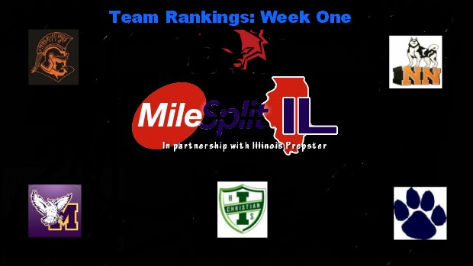

Week one of the 2013 cross country season has officially kicked off across the state of Illinois. Tony Jones takes a look at where each team ranks after their first meets of the year. Did your team make the list?

Class 1A Boys

1. Elmwood
2. St. Thomas More
3. Winnebago
4. Mt. Zion
5. Pleasant Plains
6. Tolono (Unity)
7. Monticello
8. Tremont
9. Stanford (Olympia)
10. Rochester
11. Shelbyville
12. Freeburg
13. Sterling (Newman Central Catholic)
14. Chicago (Latin)
15. Rockford (Christian)
16. Paxton -Buckley -Loda
17. St. Joseph-Ogden
18. Monmouth (Monmouth-Roseville)
19. Sparta
20. Urbana (University)

Class 1A Girls
1. Monticello
2. Decatur (St. Teresa)
3. Rochester
4. St. Joseph- Ogden
5. Petersburg (Porta)
6. Carlinville
7. Tolono (Unity)
8. Winnebago
9. Rock Falls
10. Downs (Tri -Valley)
11. Rockford (Lutheran)
12. Monmouth (Monmouth-Roseville)
13. Henry (H.-Senachwine)
14. Byron
15. Elmwood-Brimwood
16. Mt. Zion
17. Kankakee (Mcnamara)
18. Champaign (St. Thomas More)
19. Urbana (University)

Class 2A Girls
1. Yorkville
2. Normal (University)
3. Crystal Lake Central
4. Marengo
5. Glen Ellyn (Glenbard South)
6. Maple Park (Kaneland)
7. Lombard (Montini)
8. Peoria (Notre Dame)
9. Springfield
10. Lansing (Illiana Christian)
11. Lake Forest
12. Chatham-Glenwood
13. Arlington Heights (St. Viator)
14. Vernon Hills
15. Grayslake Central
16. Belvidere North
17. Springfield (Sacred-Heart Griffin)
18. Crystal Lake (Prairie Ridge)
19. Mattoon
20. Normal Community West

Class 2A Boys
1. Lansing (Illiana Christian)
2. Glen Ellyn (Glenbard South)
3. Chicago Jones Prep
4. Crystal Lake Central
5. Yorkville
6. Springfield
7. Belvidere North
8. Dixon
9. Mahomet-Seymour
10. Maple Park (Kaneland)
11. Pontiac
12. Normal (University)
13. Bensenville (Fenton)
14. Metamora
15. Vernon Hills
16. Grayslake Central
17. Chatham-Glenwood
18. Rock Island (Alleman)
19. Richmond-Burton
20. Lisle (Benet Academy)

Class 3A Girls
1. Naperville North
2. Glen Ellyn (Glenbard West)
3. Palatine
4. Geneva
5. O’Fallon
6. Orland Park (Sandburg)
7. Naperville Central
8. Barrington
9. Hinsdale Central
10. Downers Grove South
11. Winnetka (New Trier)
12. Downers Grove North
13. Hoffman Estates
14. Mt. Prospect (Prospect)
15. Park Ridge (Maine South)
16. Minooka
17. Schaumburg
18. St. Charles North
19. Lockport
20. Elmhurst (York)
21. LaGrange (Lyons Twp.)
22. Algonquin (Jacobs)
23. Gurnee (Warren)
24. Wheaton-Warrenville South
25. Wheaton North

Class 3A Boys
1. O’Fallon
2. Elmhurst (York)
3. Winnetka (New Trier)
4. Downers Grove North
5. Arlington Heights (Hersey)
6. Wheaton-Warrenville South
7. Hinsdale Central
8. Palatine
9. Naperville North
10. Naperville (Neuqua Valley)
11. Orland Park (Sandburg)
12. LaGrange (Lyons Twp.)
13. Buffalo Grove
14. Chicago Lane Tech
15. Naperville Central
16. Barrington
17. Chicago (St. Ignatius)
18. Wilmette (Loyola Academy)
19. Plainfield South
20. Glen Ellyn (Glenbard West)
21. Lincolnshire (Stevenson)
22. Highland Park
23. Wheaton North
24. New Lenox (Lincoln-Way Central)
25. Palatine (Fremd)

