What Does Pre-Season Cross Country Rankings Tell Us In The End?
AddThis Sharing Buttons
Share to Facebook
Share to Twitter
Share to Print
Share to More

Tony Jones
Nov 20, 2017
Prev
Page 5 of 7
Next
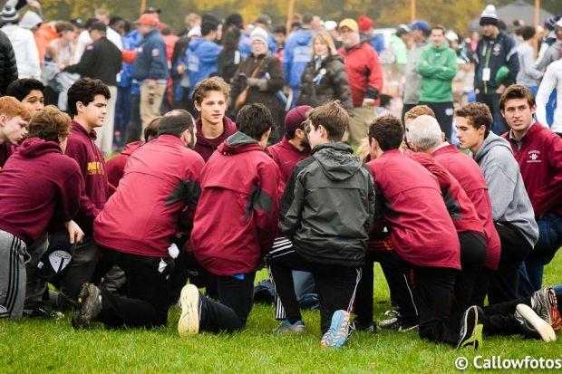
2A Boys-
Final State Championship PS Quick Summaries
1 | Mahomet-Seymour High School |  | 1 | could not be stopped after 3 in top 10 at state
2 | Normal University High School |  | 2 | only 2A team to beat Mahomet-Seymour
3 | Sycamore High School |  | 5 | great team led by all stater Stephen Poorten
4 | Springfield High School |  | 6 | strong pack running team could be in trophy mix in '18
5 | Chatham-Glenwood High School |  | 7 | the Maton family all-state streak continues with Drey Maton grabbing the final spot at 25th place
6 | Kaneland High School |  | N/R | top 10 finish and state champ Matt Richtman was icing on cake
7 | Bloomington High School |  | 11 | finish season ahead of projections; led by Austin Bicknell w/19th place at state
8 | Riverside-Brookfield High School |  | 15 | some pundits did not think a top 10 finish was possible
9 | Danville High School |  | 8 | did the Vikings sacrifice an all-state athlete for pack play? 36 scoring split earned top 10 finish
10 | Normal Community West High School |  | 14 | battled through a succession of top competition during latter portion of the season paid off
11 | Hampshire High School |  | N/R | 34 second scoring split at state was key to top 15 finish
12 | Waterloo High School |  | N/R | top performing team from southern illinois
13 | Deerfield High School |  | 24 | Matt Gold & Bradley Brodsky led team all season long
14 | Marion High School |  | 4 | pre season returns did not return favor; bad at #4 & #5
15 | Crystal Lake Central High School |  | N/R | no superstars but another great season effort
16 | Washington High School |  | N/R | team fought hard mid season and made name for themselves
17 | Illiana Christian High School |  | 25 | great state performances by top 2 runners who were all staters: Austin Ohm & Derek Van Prooyen
18 | Burlington Central High School |  | N/R | Anthony Farmer earned all-state honors
19 | Hinsdale South High School |  | 12 | tough season was highlighed by the "bandit" Brett Haffner
20 | Payton High School |  | N/R | rebounded from a rough regular season to advance to state
21 | Mather High School |  | N/R | Audiel Perez was the team's bright spot
22 | Wheaton St. Francis High School |  | 20 | team met pre-season expectations
23 | Fenton High School |  | 16 | was able to earn a trip to state despite mid season slump
24 | Marist High School |  | N/R | earned 1st trip to state in 30 years
25 | St. Viator High School |  | 13 | No one expected this team to finish last in state

