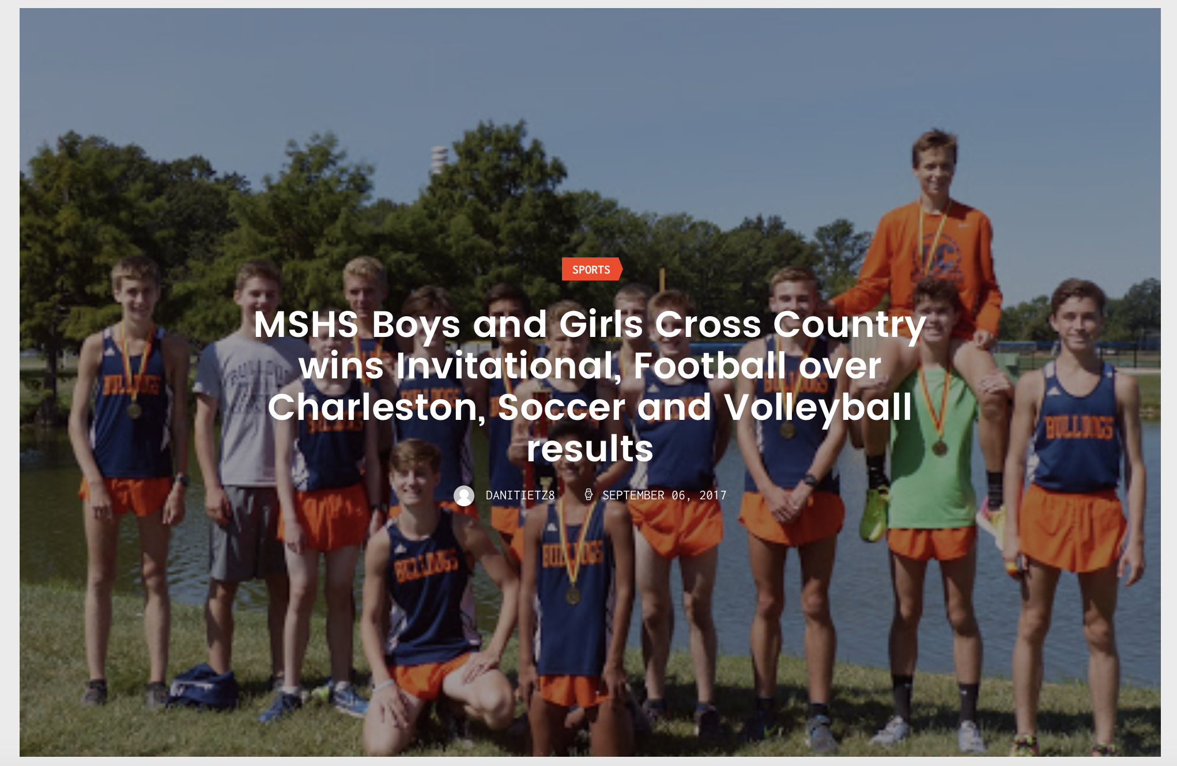

MSHS Boys’ Cross Country
Ranked #1 in the State AA, Mahomet-Seymour won the 13-team Charleston Invitational Saturday, defeating Danville, which is ranked #3 in the State AA.
Seniors Ryan Hodge, Riley Fortune, Evan Burge and Joe Churm alongside juniors Mathias Powell, Bryson Keeble and Kaelan Davis were the top seven runners for MSHS. Of the 40 medals handed out, MSHS received 9. David Wilcoski and Kyle Sheehy also received medals.

