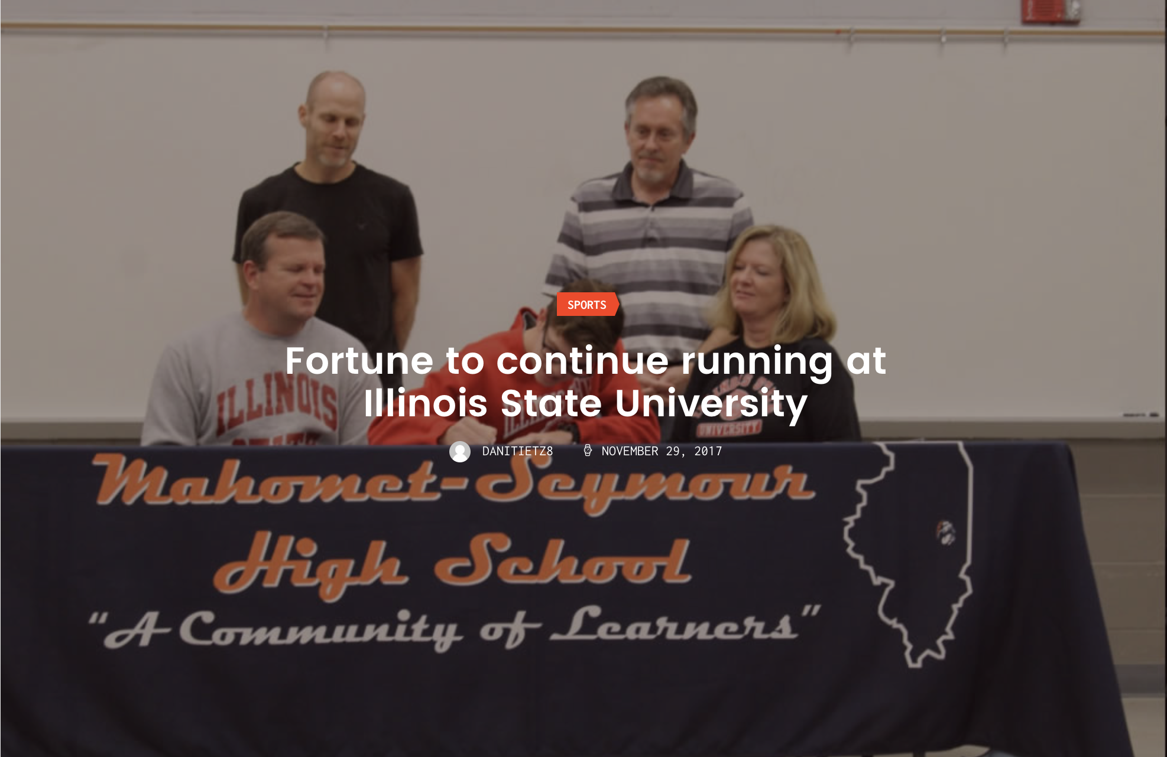

Senior Track and Cross Country Athlete Riley Fortune will be committing to continue his athletic participation on the intercollegiate level at Illinois State University. Located in Normal, Illinois, the ISU Redbirds are a member of the Missouri Valley Conference. The Redbird Head Coach is Jeff Bovee (8th season).
Riley has been an integral part of the most successful 4-year run in the history of the Mahomet-Seymour High School Boys Cross Country Program; capturing 4 consecutive I.H.S.A. Class 2A team trophies, including back-to-back State Championship for the Fall 2016 and Fall 2017 seasons. As an individual, Riley is a 4-year varsity letter-winner who earned All-Conference honors in the Corn Belt Conference as a junior (2nd Place – Fall 2016) and in the Apollo Conference as a senior (3rd Place – Fall 2017). Fortune has also earned All – State honors two times, first as a junior in 2016 (13th Place) and again as a senior in 2017 (6th Place). Outside of Conference Meets and the I.H.S.A. State Tournament Series, Riley has been an individual medalist 25 times. In Track and Field, Fortune has earned All-State honors twice, both times as a member of the Bulldog 4 x 800 Meter Relay team. His personal best time in the 800 (1:56.91) ranks third best in school history.
Riley is the son of Tom and Mary Fortune of Mahomet and plans to major in Technical and Engineering Education.

