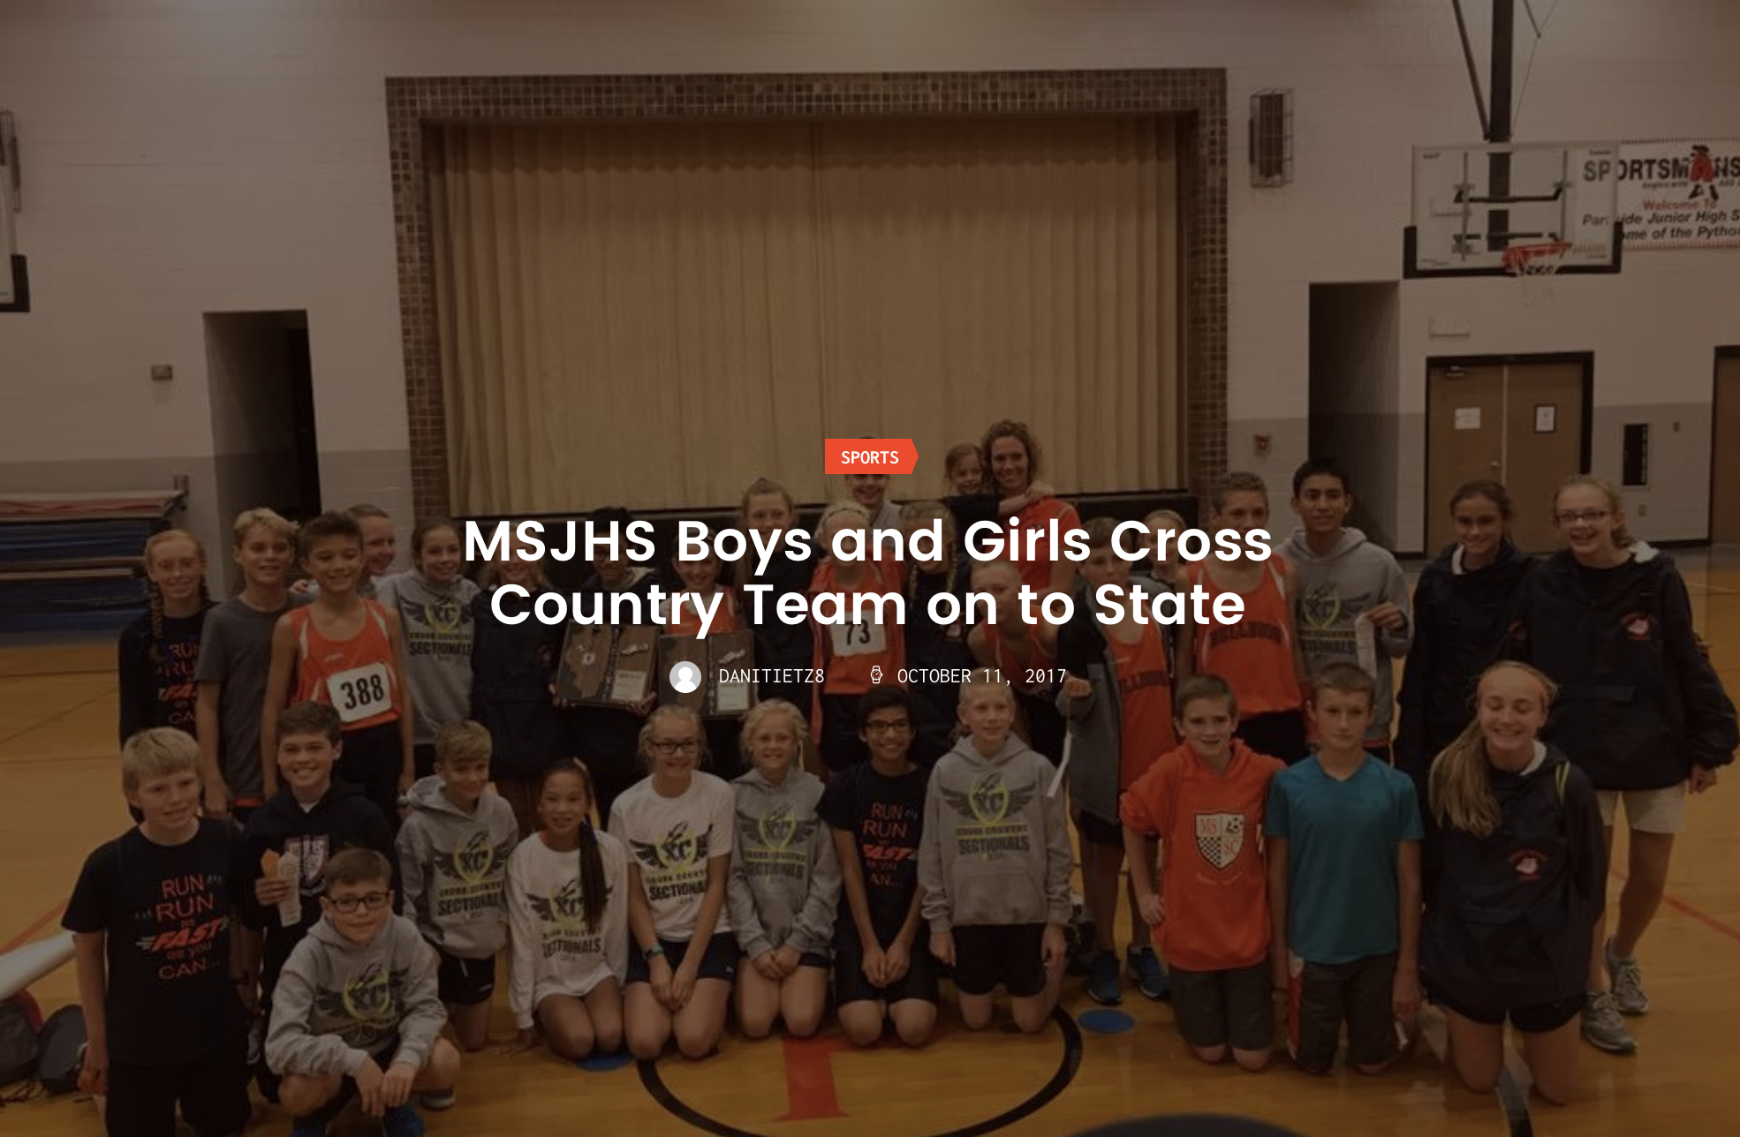

On Saturday afternoon, MSJHS traveled to Normal Parkside to compete in a tough 3A sectional meet.
With a rainstorm looming, the Bulldogs took to the line in some very strong winds.
The girls’ team went out with confidence and placed 3 in the top 10, with Elizabeth Sims leading the way. This alone qualified them for a state position. But it was Delaney King and Grace Lietz seventh and ninth place finishes that qualified the whole team for state.
With an extreme amount of excitement, Coach Bails and Martin met the boys’ team at the starting line to discuss how the team was physically ready now and just had to add in the power of the mind in order to reach our goal of going to State. WKyle Nofziger led the way for the boys’ team, finishing in the 10 spot and automatically qualifying for state as an individual. His team had bigger plans and packed it up allowing for us to advance as a team.
Kyle Nofziger led the way for the boys’ team, finishing in the 10 spot and automatically qualifying for state as an individual. His team had bigger plans and packed it up allowing for the Bulldogs to advance as a team.
MSJSH will be back on the race course on Saturday at Normal Parkside in the IESA State Competition.
Here are the Bulldog results:
Girls’ Team Race (14 teams)
1st- Normal Kingsley (46)
2nd- Mahomet-Seymour (53)
3rd- Normal Parkside (60)
Girls’ Individual Results (96 runners)
4th place- Elizabeth Sims (12:24)
7th place- Delaney King (12:36)
9th place- Grace Lietz (12:47)
13th place- Klein Powell (13:01)
20th place- Emily Bednar (13:16)
21st place- Ella Scott (13:19)
26th place- Chloe Allen (13:22)
Boys’ Team Race (14 teams)
1st place- Normal Parkside (46)
2nd place- Bloomington Evans (64)
3rd place- Mahomet-Seymour (99)
Boys’ Individual Results (96 runners)
10th place- Kyel Nofziger (11:27)
14th place- Justin Straub (11:34)
22nd place- Joseph Scheele (11:45)
23rd place- Anthony Ramirez (11:46)
30th place- Gabe Difanis (11:50)
33rd place- Kai Jones (11:52)
44th place- Taylor Fan (12:01)

