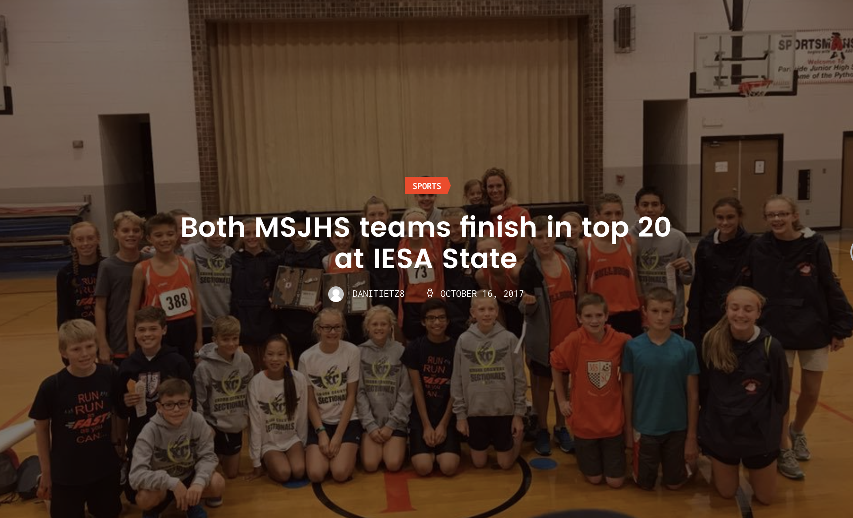

With over 125 schools that started the trek to the state meet back in August, both of the MSJHS Bulldog teams finished the season in the top 20 at the IESA State meet Saturday.
The girls’ team placed 16th, while the boys’ team placed 19th at the state meet. A few of the runners even had personal records in this very crowded meet.
Here is a look at the results:
Girls Varsity (234 of the state’s best runners):
Elizabeth Sims, 66th place- 12:29
Grace Lietz, 102
Delaney King, 103
Klein Powell, 115
Ella Scott, 128
Emily Bednar, 177
Chloe Allen, 195
Boys Varsity (235 of the state’s best runners):
Kyle Nofziger, 67th place- 11:25
Anthony Ramirez, 105
Justin Straub, 148
Taylor Fan, 164
Gabe Difanis, 168
Kai Jones, 172
Joseph Scheele, 209

