Midwest Region Boys Preseason XC Rankings 2017
Aug 15th, 6:04pm

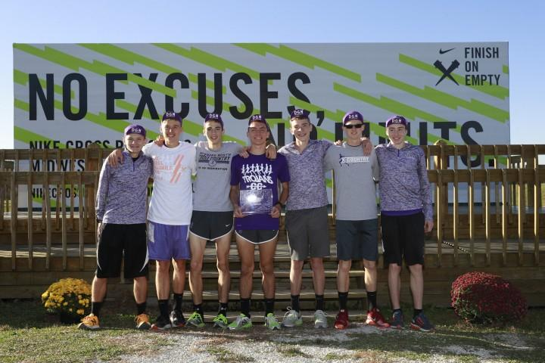

Big year in Illinois includes high expectations for DG North
By Paul Schmitz of DyeStat
Boys Midwest Season Preview
For the second year in a row, teams from Illinois completely dominated the competition at NXR Midwest. In 2015, Illinois finished with the top three teams in the region and in 2016 it was the top four. Illinois joined Utah, Texas and California as states sending three teams to NXN in 2016.
Class 2A Mahomet-Seymour earned an at-large bid joining Neuqua Valley and Downers Grove North in Portland.
Illinois is going to be strong once again and could possibly sweep the top four regional spots in Terre Haute. But Carmel of Indiana is also a contender. The Greyhounds have a solid lineup, with their top four and five of the top six returning.
The top spot in the region belongs to Downers Grove North IL. DGN came on strong at the end of 2016, placing second in the Illinois Class 3A state meet, second at NXR Midwest and 12th in Portland in the school's first trip to nationals. North pencils out to be better than 2016 and is primed for a big season.
It is a two-team race in Ohio, with Hudson and Medina vying for the top spot in the Buckeye State. Hudson has a slight edge, but the Medina Bees have a great pack-running team and their top four returners were within two seconds of one another at the state meet.
The door is wide open in Missouri with the top two teams from 2016, Rockhurst and Rock Bridge, both graduating four from their respective top fives. Blue Springs, which returns its top six runners from a fourth-place finish in the largest classification, appears to be the top team in Missouri. Blue Springs, however, finished 16th in the NXR Midwest meet and has a lot of ground to make up in order to compete with the top teams in Illinois. Blue Springs is led by Victor Mugeche, who clocked a 9:12 PR in the 3,200 in the spring.
Michigan has yet to qualify a boys team for NXN, partially because of state association rules. Ann Arbor Pioneer in Division 1 and Corunna in Division 2 are likely the top two teams in the state.
1. Downers Grove North IL. North finished 12th at NXN last year and much more is expected this fall. The Trojans return five of their top seven and a top-five national ranking is within reach. Behind strong pack running they also have quality depth with seven runners going 9:45 or faster for 3,200 meters on the track this spring.
2. Carmel IN. After finishing 53rd in the state cross country meet in 2016, Ben Miller had a terrific spring, running a 9:10 3,200 and finishing third in Indiana state meet. If he and his teammates can translate track times to the cross country course, the Greyhounds will be in line for Carmel’s fourth trip to Portland after qualifying in 2012, 2013 and 2014.
3. York IL. The team with nine trips to nationals is back in the mix for a chance to qualify for the first time since 2012. The Dukes senior-dominated team, led by Charlie Kern, has a solid top five and there is also enough depth in this region for a possible at-large bid if the number three team can stay close to the top two.
4. Neuqua Valley IL. It was a great run for a talented group of seniors last year for Neuqua Valley. As juniors they had qualified for NXN in 2015. In 2016, NV was ranked near the top of the country all season and finished fifth in Portland. With six of the top seven graduating, the Wildcats will have to reload. Last year they had a killer pack and this year they have a front-runner in Zach Kinne, who ran 9:11 in the 3,200.
5. Hudson OH. The top team in Ohio finished second to Solon in 2016 and returns five of its top seven. Hudson is led by 9:17 3,200-meter runner and junior Adam Beucler. A few more of the school's top runners are underclassmen who are growing into key roles.
Watchlist:
Downers Grove South IL
Medina OH
Mahomet-Seymour IL
Wheaton Warrenville South IL
Ann Arbor Pioneer MI
Corunna MI

