XC Zone 2017 National Lists - Boys Pre-Season
Published by
Mike Newman Aug 18th, 2:18pm

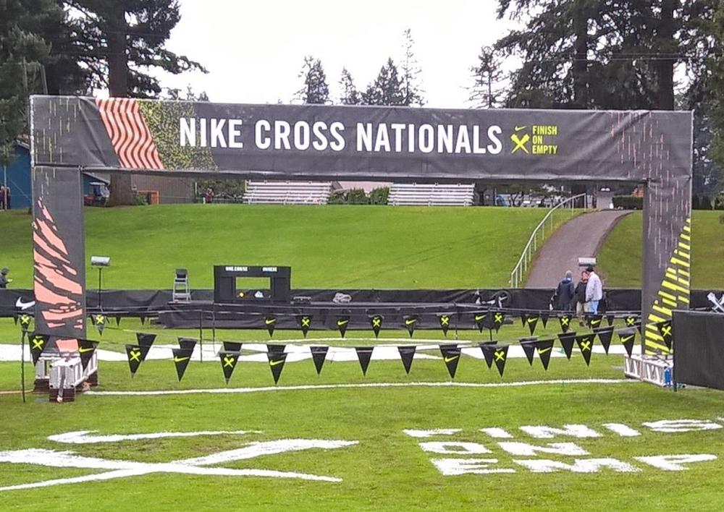

Here is a list of the top 50 national pre-season teams. Top 25 lists will be updated every week beginning the week of September 10, 2017
 |  |  | 2017 XC Zone
 |  |  | Boys National List
 |  |  | Pre-Season
TW | LW |  | School | State |  | Regional
1 |  |  | Purcelville Loudon Valley | VA |  | Southeast
2 |  |  | Downers Grove North | IL |  | Midwest
3 |  |  | Temecula Great Oak | CA |  | California
4 |  |  | Eastvale Eleanor Roosevelt | CA |  | California
5 |  |  | Carmel | IN |  | Midwest
6 |  |  | Plymouth Wayzata | MN |  | Heartland
7 |  |  | Louisville St. Xavier | KY |  | Southeast
8 |  |  | San Jose Bellarmine Prep | CA |  | California
9 |  |  | Central Point Crater | OR |  | Northwest
10 |  |  | Lincroft Christian Brothers Academy | NJ |  | Northeast
11 |  |  | Dana Point Dana Hills | CA |  | California
12 |  |  | Conroe The Woodlands | TX |  | South
13 |  |  | Cary Green Hope | NC |  | Southeast
14 |  |  | Princeton | NJ |  | Northeast
15 |  |  | Elmhurst York | IL |  | Midwest
16 |  |  | Burnt Hills-Ballston Lake | NY |  | New York
17 |  |  | Orem Timpanogos | UT |  | Southwest
18 |  |  | Los Angeles Loyola | CA |  | California
19 |  |  | Naperville Neuqua Valley | IL |  | Midwest
20 |  |  | Springville | UT |  | Southwest
21 |  |  | Alpharetta Milton | GA |  | Southeast
22 |  |  | Portland Jesuit | OR |  | Northwest
23 |  |  | Highlands Ranch Mountain Vista | CO |  | Southwest
24 |  |  | Brentwood Academy | TN |  | Southeast
25 |  |  | Veradale Central Valley | WA |  | Northwest
26 |  |  | Bozeman | MT |  | Northwest
27 |  |  | Mahomet-Seymour | IL |  | Midwest
28 |  |  | Jacksonville Bolles School | FL |  | Southeast
29 |  |  | Fort Wayne Carroll | IN |  | Midwest
30 |  |  | LaGrange Lyons Township | IL |  | Midwest
31 |  |  | Phoenix Desert Vista | AZ |  | Southwest
32 |  |  | Blue Springs | MO |  | Midwest
33 |  |  | Winter Haven Trinity Prep | FL |  | Southeast
34 |  |  | Saint John's Shrewsberry | MA |  | Northeast
35 |  |  | Arlington Heights Hersey | IL |  | Midwest
36 |  |  | Brentwood | TN |  | Southeast
37 |  |  | Westport Staples | CT |  | Northeast
38 |  |  | Monument Palmer Ridge | CO |  | Southwest
39 |  |  | American Fork | UT |  | Southwest
40 |  |  | Painted Post Corning | NY |  | New York
41 |  |  | Gig Harbor | WA |  | Northwest
42 |  |  | Fairport | NY |  | New York
43 |  |  | Saratoga Springs | NY |  | New York
44 |  |  | Providence LaSalle Academy | RI |  | Northeast
45 |  |  | Fayetteville-Manlius | NY |  | New York
46 |  |  | Wheaton-Warrenville South | IL |  | Midwest
47 |  |  | Hudson | OH |  | Midwest
48 |  |  | Council Rock North | PA |  | Northeast
49 |  |  | Corunna | MI |  | Midwest
50 |  |  | Severna Park | MD |  | Southeast

